

**Names:**

Gerson Rodríguez

José Guadrón

**Date:**

April 21st, 2019

**Course:**

Web Systems

**Instructor:**

Ms. Carolina Carjaval

Content

Introduction 3

Objectives 4

General Objetives 4

Specific Objectives 4

System Requirements 5

Database Structure 6

Data dictionary 6

Table: User 6

Table: Students 7

Table: Area_students 7

Table: Areas 7

Table: Department 8

Use case diagram 8

Implementation Diagram and Development Components Diagram 9

Relevant things about the code 9

Steps to install and run the Keiser University of Work Study Hours website 10

General recommendations 12

Conclusion 13

# Introduction

For a long time, the human being has chosen to automate the majority of tasks that were performed manually, that is, tend to find a way to make things much more manageable. For example, orders were requested personally in fast food places. Nowadays, many fast food restaurants or even traditional food restaurants choose to automate their services and use automated programs to order orders from customers.

Due to the aforementioned, during a three month students from Web Systems course have being working on a web page to automatize one of the essential processes of Keiser University, that is, the recording of the work hours of each of the students. For this, we have decided to create a web page, which carries the automated record of each of the hours worked by the students. In this way, the people in charge can accomplish much more comfortable with this type of registration without having to do many things that they had to do before. For example, they may review, delete, edit, update and add individually each record of working hours performed by students without much work in a digital manner in which the information is more accurate than manually.

This project will be carried out with all the lessons learned from students in the course of web systems taught by Miss Carolina Carvajal in Keiser University, in this project we will be able to observe each of the things learned throughout the semester. From changing a simple text using CSS to being able to modify entities of the database and more complex processes.

# Objectives

## General Objetives

* General objective: to create, design and develop a web page to help Keiser University students to have an up to date records of their work-study hours easily. At same time, helping Human Resources area to record all student’s records without having to store each record manually.

## Specific Objectives

* To keep records of the work study hours
* To notify the students their progress with the hours by watch it on the web page
* To help them to have a record for their hours saved in their devices in any case they need it
* To make Human Resources personnel work easier.

# System Requirements

1. The platform should be capable of handling a sign page
2. The website should be able to connect to a database
3. The platform should have a database
4. The web page should have a bottom to log in and to log out.
5. Students have to be able to see their work study hours made on previous months
6. Administrator should add, edit, update and delete data.
7. Students can store their study hours.
8. Administrator can set new users and administrator
9. System can validate users and administrators
10. The website should be responsive
11. It could be capable to run in different navigators
12. It should have a professional web design using CSS
13. It has to show appropriate information in Public profile (users).

# Database Structure

MySQL Workbench

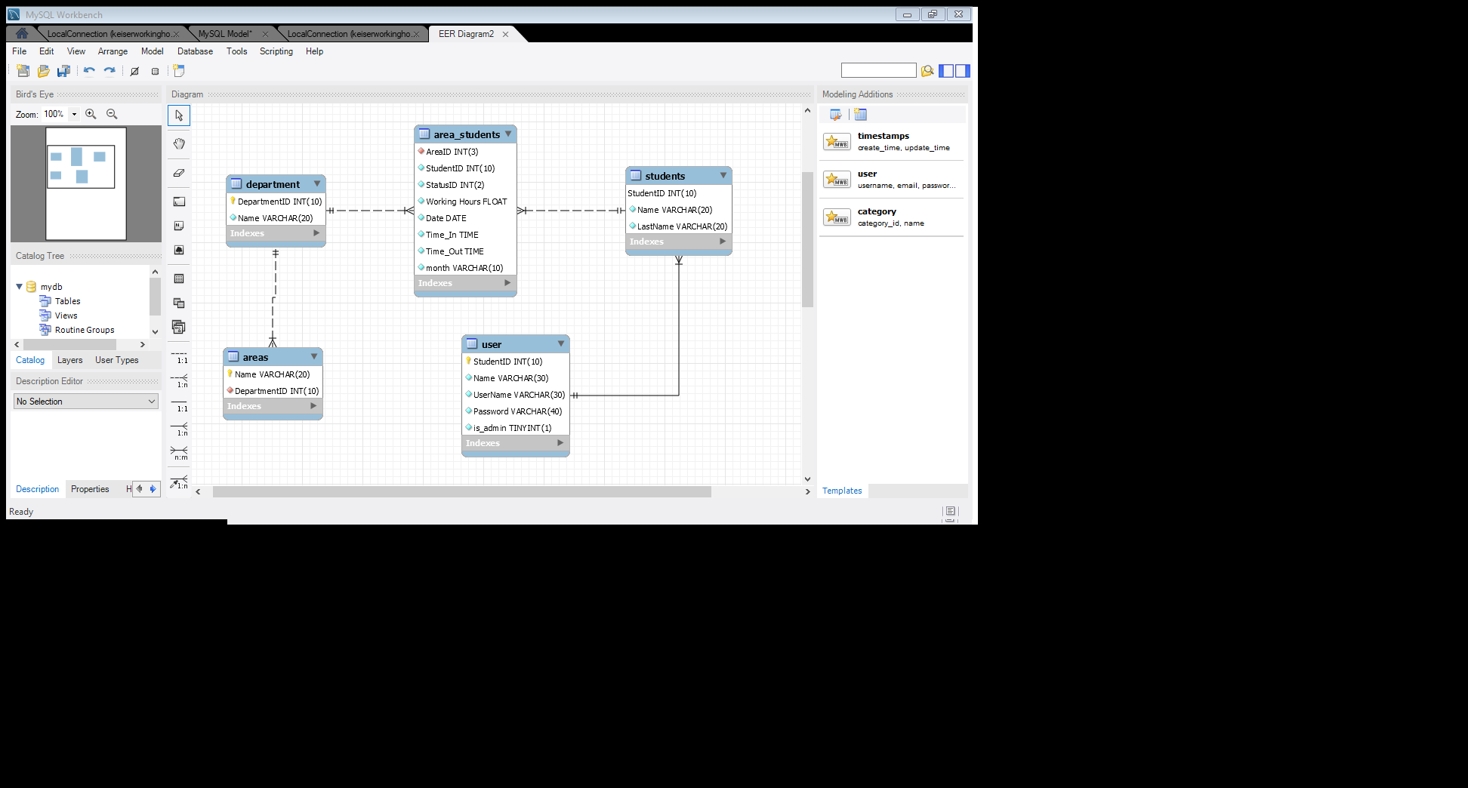

# Data dictionary

## Table: User

|  |  |  |  |  |
| --- | --- | --- | --- | --- |
| Field Name | Data Type | Field Size for display | Description | Example |
| StudentID | Integer | 10 | Unique ID of each user | 7720366 |
| Name | Varchar | 30 | Name of the user | Jose Guadron |
| UserName | Varchar | 30 | Name of the user inside the web page | joseguadron |
| Password | Varchar | 40 | Password of the user | fe9f2f3dacb763b46c9a2760b540a421 |
| Is_admin | Tiny Interger | 1 | To validate if it is a user or a admin | 1 |

## Table: Students

|  |  |  |  |  |
| --- | --- | --- | --- | --- |
| Field Name | Data Type | Field Size for display | Description | Example |
| StudentID | Integer | 10 | Unique ID of each user | 7720366 |
| Name | Varchar | 20 | Name of the user | Jose |
| Lastname | Varchar | 20 | Last name of the user | Guadron |

## Table: Area_students

|  |  |  |  |  |
| --- | --- | --- | --- | --- |
| Field Name | Data Type | Field Size for display | Description | Example |
| AreaID | Integer | 3 | Unique ID of each area | 1 |
| StudentID | Integer | 10 | Name of the user | 7720366 |
| StatusID | Integer | 2 | To check the status of the working hours | 1 |
| Working_Hours | Float |  | The time the user have worked | 42.04 |
| Date | Date |  | The date the user have worked | 2019-04-20 |
| Time_In | Time |  | The time the user enter to work | 12:05:00 |
| Time_Out | Time |  | The time the user exist to work | 12:45:00 |
| month | Varchar | 10 | To show the month of the working hours | April |

## Table: Areas

|  |  |  |  |  |
| --- | --- | --- | --- | --- |
| Field Name | Data Type | Field Size for display | Description | Example |
| Name | Varchar | 20 | Name of the area | Admissions |
| DepartmentID | Integer | 10 | Unique ID of each department | 6 |

## Table: Department

|  |  |  |  |  |
| --- | --- | --- | --- | --- |
| Field Name | Data Type | Field Size for display | Description | Example |
| DepartmentID | Integer | 10 | Unique ID of each department | 6 |
| Name | Varchar | 20 | Name of the department | Student Life |

# Use case diagram

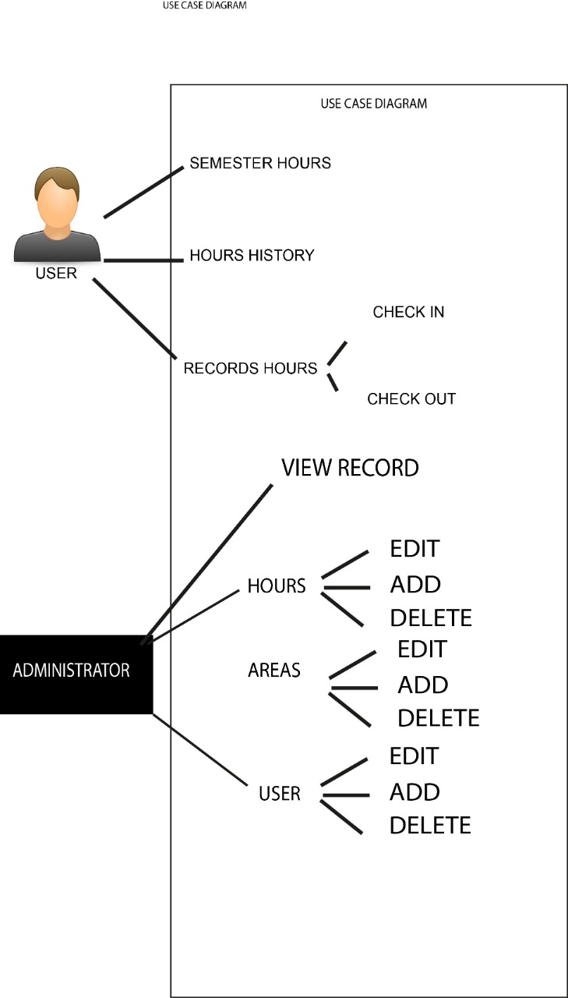

# Implementation Diagram and Development Components Diagram

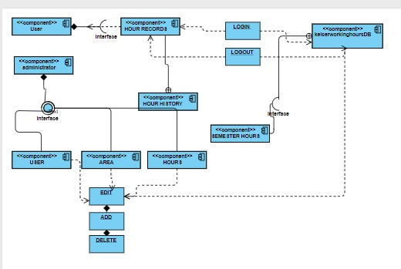

# Relevant things about the code

The code was created by José Guadrón and Gerson Rodríguez, students of Keizer University Latin American Campus, during the course of Web Systems. The project performs the following functions: Upon entering the project, you can see a login which is validated to determine if the user exists within the database. If it exists, it allows access either as administrator or user depending on the credentials granted within the database. In the event that a user tries to enter from the administrator tab, it will not allow access as it is not an administrator, otherwise the same will happen, if an administrator for some reason tries to enter from the login page as a user not will allow you access because you are not a user but an administrator.

When the credentials are confirmed, that is, the same values ​​are found in the database for both the user and his password, the system allows him access to the tabs requested in this case if he is a user he could access to see his hours of work, their records and be able to record new work hours. On the other hand, the administrator allows access in a broader way to the entities of the database, allowing you to modify, delete, update each of each of the elements that are in the database.

# Steps to install and run the Keiser University of Work Study Hours website

1. First, you have to make sure you have installed the following programs on your PC:
2. Xampp that will be responsible for executing the web page correctly on the localhost on the pc. Link <https://www.apachefriends.org/index.html>
3. The second necessary program is Mysql Workbench that will be responsible for the database we will occupy for the project (this information will be expanded later). Link <https://www.mysql.com/products/workbench/>. You can also do it from Phpmyadmin from the same Xampp.
4. Second, you must enter the GitHub link that we leave below: <https://github.com/JoseGuadron/Work-Study-Hours> where the repository of the entire project is located.
5. You must download each of the files that are in that repository.
6. You have to create a new folder in your localhost “Websystems” if you want or any other name.
7. Send all files you have downloaded to your localhost folder to access them.

1. Once you have downloaded and installed all the programs that will be presented in the previous steps, you must enter the Xampp controller and start the phpmyadmin server to the Apache server.

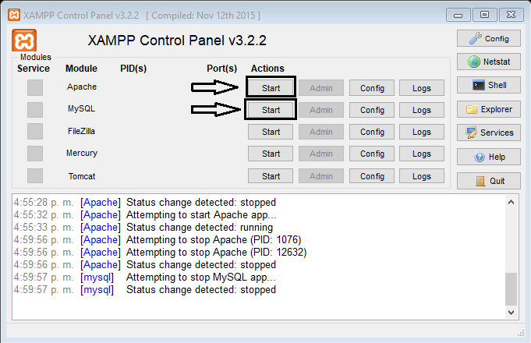

1. Press the admin button in Phpmyadmin.

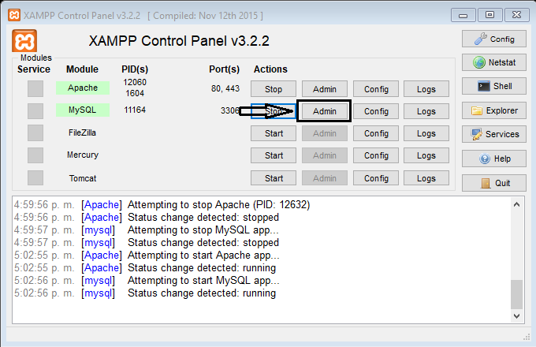

1. Once inside this web page, on the left side, the already created databases will appear, choose **New** to create the project database.

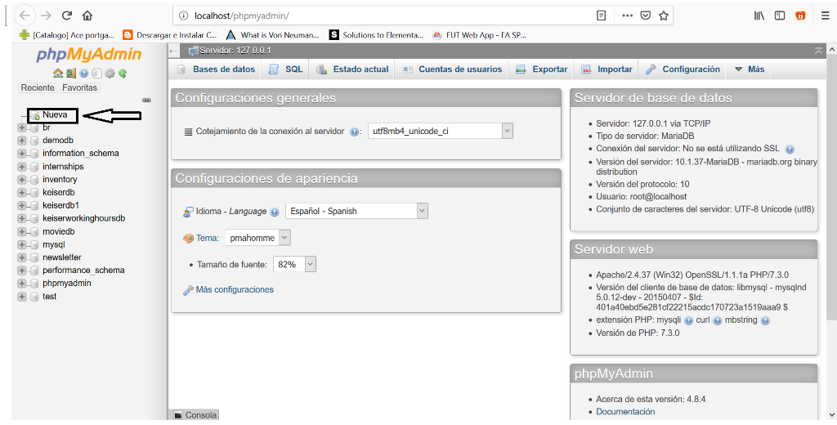

1. Assign it the name of keiserworkstudyhoursdb and then import it from the database that is inside the repository.
2. Once the database has been created with the name assigned to it.
3. After that, we go to said database, and at the top, it appears a button that says import, we will click on it.

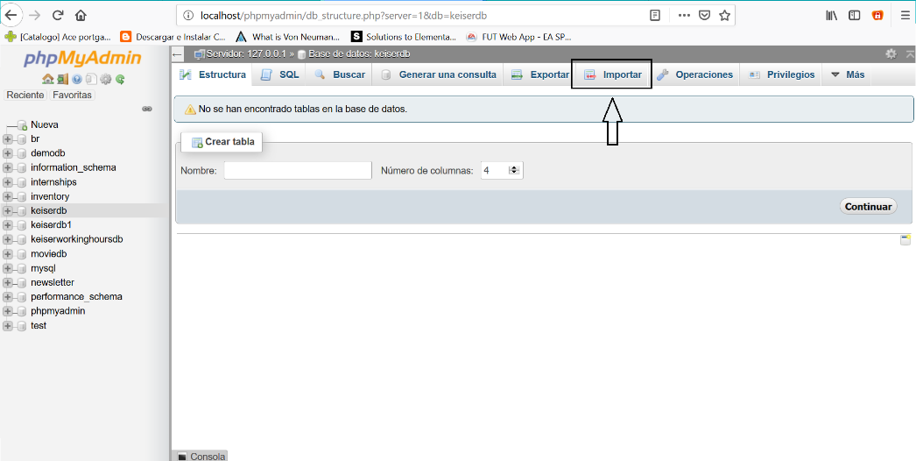

1. Now we have to select the database file, that is, the file keiserworkinghoursdb.sql that is found within the repository.
2. Having done each of the previous steps all we have left is to start Apache administrator in Xampp.
3. Enter where our project files are located
4. Run it

# 

# General recommendations

1. As in any project, you always have to see some recommendations to make it work in the best way.
2. The first recommendation is to be careful with the use of variables used in each of the fields because each of the areas was each of the fields contains a type of variable already defined example working_hours uses the kind of variable float, if a non-numeric character is entered, it will give an error.
3. Another recommendation would be the proper use of each of the tabs, that is, not force any page to perform an activity for which it is not programmed.
4. Being a web application many times the cache of such pages at work in a wrong way. Therefore, if any of the pages are not working the way you want it is advisable to leave the page and reload to check if the cache was not convenient, in most cases that solves the problems
5. If any of the variables seem very unfamiliar do not know precisely what you can go to the section of Data dictionary and there to check what operation is done or what that variable is used within the web page.

# Conclusion

After finishing the project, some important conclusions have been reached. First, although not all the requirements raised at the beginning of the project were met due to some internal problems of the equipment, a large part of them were reached, with which the project can operate and provide utility to the user. The program can be used successfully for what was planned at the beginning of the semester. In other words, students can keep track of the working hours of Keiser University students in a quicker and easier way than they do today in Human Resources.

In addition, each one of the knowledge of the students could be appreciated at the end of this course. Demonstrating that they can put them into practice and carry out a very well structured project on their own.